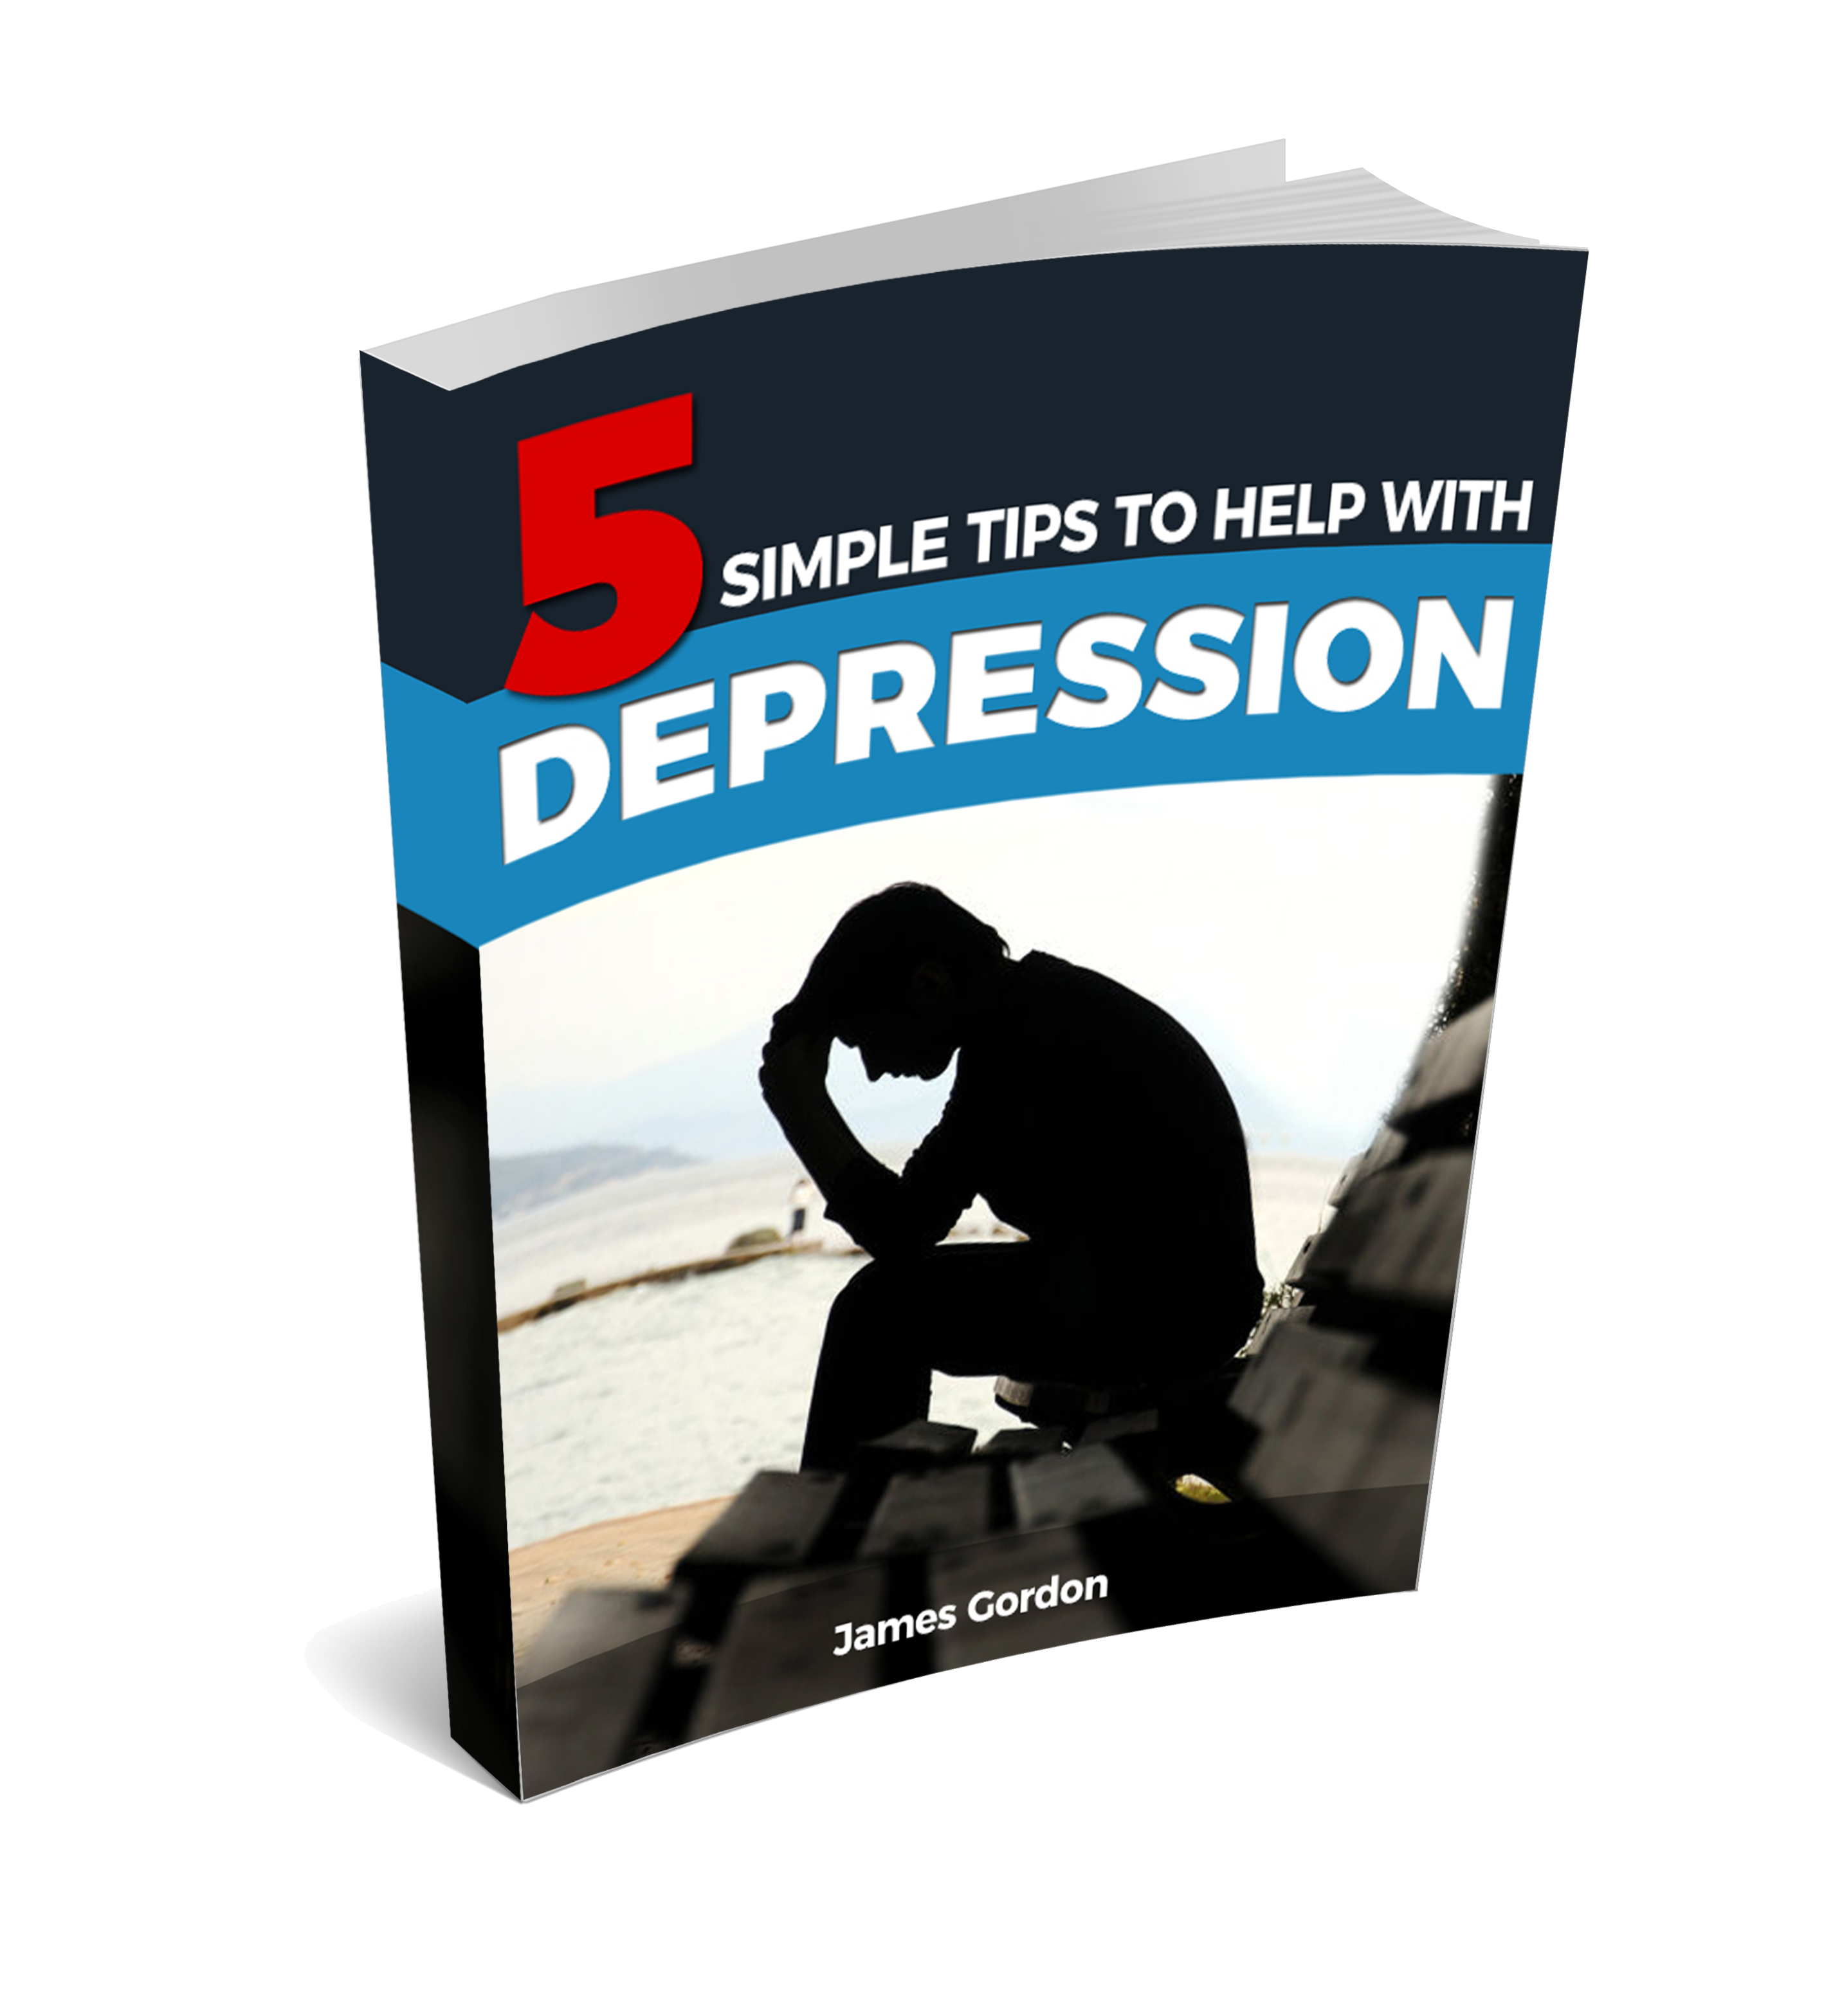

# Copyright Notice

No part of this report may be reproduced or transmitted in any form whatsoever, electronic, or mechanical, including photocopying, recording, or by any informational storage or retrieval system without expressed written, dated and signed permission from the author. All copyrights are reserved.

# Disclaimer and/or Legal Notices

The information provided in this book is for educational purposes only. I am not a doctor, and this is not meant to be taken as medical advice. The information provided in this book is based upon my experiences as well as my interpretations of the current research available. The advice and tips given in this course are meant for healthy adults only. You should consult your physician to insure the tips given in this course are appropriate for your individual circumstances. If you have any health issues or pre-existing conditions, please consult with your physician before implementing any of the information provided in this course. This product is for informational purposes only and the author does not accept any responsibilities for any liabilities or damages, real or perceived, resulting from the use of this information.

# My Story

Hello,



If you are reading this short eBook, the chances are that you are one of the millions of people worldwide who are suffering from an extremely common and terrible illness: Depression.

In the last 30 years, depression has become so widespread that right now it is the number one reason for a person to visit their doctor or GP. It currently affects around 350 million people worldwide – that is 5% of the global population – in some countries it is more than 10%, and the problem is getting worse.

Around one million people every year commit suicide because they are suffering from depression, and every year that figure is rising at an alarming rate. By the year 2020, depression will have become the second most common cause of premature death – only heart disease will be ahead of it.

My name is James Gordon. I suffered with depression for most of my adult life. From the age of 14, bouts of depression would hit me like a tidal wave and leave me feeling out of control, weak and hopeless. Sometimes I would be depressed for just a matter of weeks, while at other times a fog of depression would envelop me for months or years at a time.

Of course, like most people suffering from depression, I didn't do much about it. I tried to talk to my family and friends at some points during my darkest spells, however I was usually met with a response like “pull yourself together!” or “just cheer up, it's not the end of the world!” Of course, these responses just seemed to make me feel worse, like there was something wrong with me and that I was weak. Ultimately, I stopped talking about it. I learned to just hide what I was truly feeling behind a false smile.

Then, at 35 years old, I witnessed an extremely traumatic event. A friend I was staying with in America committed suicide because he was suffering with depression. He shot himself. It was horrifying.

When I returned home to the UK a few weeks later, everything seemed OK for a couple of months, but then my life quickly spiraled out of control. Months went by without me even leaving the house or opening the curtains. I lost contact with all of my friends and had only a feeling of nothingness and suicidal thoughts to keep me company.

Finally, I visited the doctor and he diagnosed me with Post Traumatic Stress Disorder (PTSD), along with severe depression.

During the following two years, a number of doctors pumped me full of drugs that had all manner of side effects. Fluoxetine and the other SSRI's they tried me on made me an insomniac, so they gave me more pills to 'help' me sleep. Those, amongst other side effects, made me lose my appetite, so they gave me more pills to treat that. In the end I was taking 5 or 6 different drugs on a daily basis, all of which made the underlying feelings I was having because of depression and PTSD, of being out of control and having no hope or goals, even worse.

I was then sent to see a psychiatrist, who over the course of 6 months (which cost a lot of money), did nothing to help me at all.

I actually felt worse after each visit, each time I would leave feeling like a complete and utter failure. In short, the doctors and specialists didn't help me – they just threw their pills and potions at my symptoms, at no time did they try to treat the cause of my depression.

One day, while sitting in the doctor's office and feeling totally frustrated, I snapped and walked out of the surgery, telling the Doctor I was going to sort this problem out myself. I just never felt like they did anything to really help me, so decided I had to help myself instead. There had to be another way to treat depression than just prescribing drugs which were made in a lab by men in white coats.

I returned home and started to research everything about depression that I could possibly find. I trawled the Internet and read thousands of articles on the subject. I searched through dozens of medical books, consulted many specialists, downloaded dozens of e-books and systems written by life coaches and gurus, watched hundreds of hours of videos, talked with people who battled with depression themselves who had recovered, and met with people who had attempted suicide and survived.

Throughout all of this, I was constantly writing down notes and making observations. In my search for answers I made many discoveries which astounded me, things which the mainstream media just didn’t report.

The following report consists of my top tips that anybody can do, which will help if they are suffering with depression.

# 5 Simple Tips to Help with Depression

## Tip #1: Stand up Straight

OK, so this may seem a bit silly, but trust me, it works.

Have you ever noticed how somebody with depression walks and holds themselves? They will usually be slouched, with their shoulders hunched forward and their eyes looking in the direction of the floor.

This has a massive effect on your mood. Some might say that this posture is a result of a depressed or negative mood, but as with almost every symptom of depression, thoughts, feelings and actions are all connected and fuel each other. Being hunched over in this way is not just a symptom of depression, it is also a cause.

Making sure you stand (or sit) up straight helps to break the cycle of depression and give you an almost immediate 'lift' in emotions.

You will become more positive and pro-active almost immediately as a result.

It is without doubt the most important piece of advice I can give to anybody who is suffering from depression and is actually something I make sure I am doing ALL the time. When you have good posture, you become more positive, more alert and more pro-active, which goes a long way to melting the blues away.

The benefits it will have on your physical health as a result will also be very positive. It is medically proven that people who have good posture get less headaches, joint and back pain.

## Tip #2: Talk to Somebody

When I was suffering from depression, one of the most harmful things I did to myself was to shut myself away from the world and become reclusive.



Not only did it have a terrible effect on my health, but my relationships suffered as a result. In some cases, relationships with friends broke down beyond repair.

What I did not realize is just how helpful actually talking to somebody about my problems and how I felt could be. There is an old saying that “a problem shared is a problem halved”, and to some extent that is true. It can be a very hard thing to do to open up and actually talk to somebody about your feelings. Sometimes, it is difficult to actually describe what it is you are feeling and what is making you depressed.

However, the stigma surrounding depression and other mental illnesses is not what it once was; it has diminished quite a lot in the last few years. This is due in part to the huge amount of press reports on depression, especially surrounding famous people who have struggled with it, which has changed a lot of people's view on the subject.

Depression is no longer the taboo subject it once was. People in the world today understand that it can affect anybody, regardless of their age, sex, background or social standing.

If you open up to just one person, especially if that person is a close friend or family member, it can really help to start to lift the fog in your mind. If talking to someone close to you seems a bridge too far, then consider talking to a doctor or GP instead, it really can help a great deal.

## Tip #3: Challenge Negative Thoughts

Negative thoughts are often a catalyst for depression. Negativity in your thoughts often leads to negative emotions, which in turn leads to negative actions (or inactions). These negative actions of course, then mean the likelihood of even more negative thoughts increase, starting the whole depression cycle over again.

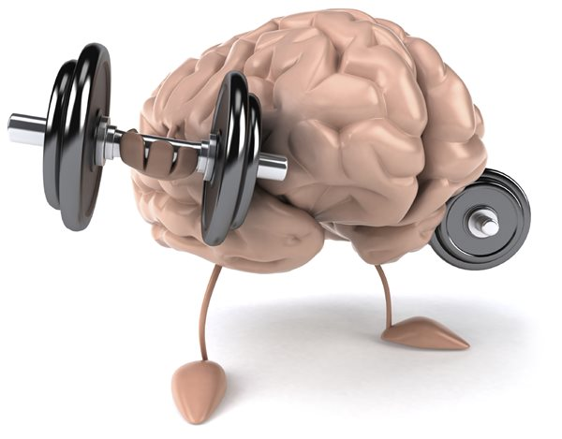This is why people often say that depression is like “spiraling out of control” - each part of the process feeds the next part and it just keeps getting worse and worse as a result. Breaking this cycle of depression is hugely important in order to stop the seemingly never-ending spiral. The way to start is by challenging those negative thoughts in the first place.

If for instance, you had a thought of “I am such a failure”, this would most likely lead to negative emotions such as sadness and low self-confidence.

In turn, this would then lead to you being less likely to do anything pro- active, which then obviously leads to even more negative thoughts.

Challenging that initial negative thought goes a long way to breaking the cycle, which will then lead to a more positive emotion and ultimately, more positive actions and a happier existence.

So next time you find yourself having a negative thought, ask yourself “Is that really true?”

Imagine how you would feel if instead of “I am such a failure”, you thought “The most successful people in the world, are usually those who have failed the most”? Much better, I am sure.

## Tip #4: Set Small Goals

When you are depressed, you often just don't feel like doing anything. Accomplishing even the most mundane or simple tasks can seem like you are trying to climb Mount Everest. Of course, this lack of any positive action in your life can lead to even more negative thoughts and emotions, which fuel the cycle of depression further. Setting and achieving small goals, can go a long way to improving your self-esteem and lifting your mood.



With this in mind, each day set yourself a small goal and make sure you do it. Attaching a positive 'anchor' to achieving the goal will help with this. What I mean by 'anchor' is to have a meaning or belief that what you will get from doing the task will have a positive outcome.

For instance; your goal for one day might be “to get cleaned up, have a shower and put on some nice clothes”. A positive anchor to help you and provide the motivation to do this might be to think, “when I look and smell nice, I feel nice”.

Stay clear of attaching negative anchors to your goals though. Anchoring or attaching a belief of “so I stop feeling like a slob”, is a negative-fueled thought. Stay away from thoughts of “stop” or “lose” and attach anchors that include positive words such as “start” and “gain” instead.

Achieving small tasks in this way really has a compounding effect on your life if done on a daily basis and can lead to much healthier and more positive thoughts and emotions.

Small goals, if done consistently and on a regular basis, can lead to staggering long-term results.

## Tip #5: Exercise

Regular exercise helps with depression in two distinct ways.

Firstly, exercise releases endorphins, which are the bodies' 'happy' chemicals. This release of endorphins gives an immediate lift in your mood which is often referred to as a “runners' high”. This also helps you sleep better and lowers stress levels.



Secondly, there are more long-term benefits associated with regular exercise. It helps to increases energy levels, improves muscle tone and strength, reduces body fat and makes you look fit and healthy, all of which go a long way to improving self-esteem and confidence.

According to a report in the Journal of Psychiatric Practice, for the best results it is advised to partake in 45 to 60 minutes of aerobic exercise 3-5 times a week, which gets the heart pumping at 50-85 percent of the maximum heart rate.

You don't have to train to become an Olympic athlete for exercise to have a positive effect though, the above is just a guideline on what will give you the best results.

Many studies have shown that walking just 30 minutes per day has a hugely positive effect on your mental health and will also get you outdoors instead of locked away in a darkened room.

So, next time you have 30 minutes to spare and are about to sit down to read a magazine, or watch a re-run of 'Friends' on TV, or play a game of 'FIFA' on your X box, why not go for a walk instead?

It just might just be exactly what your mind and body needs.

So what’s next?...

# The Next Steps:

# Destroy Depression *FOREVER!*

If you employ the 5 tips mentioned in this report into your life on a daily basis, you should notice a big improvement in your mood, and any depression in your life should start to ease.

Depression is cyclical though, in many people it comes and goes in cycles, and often creeps up on them without them noticing.

To make sure you do everything in your power to free yourself from depression forever, it is important that you educate yourself on exactly what depression is, and on everything that you can do on a daily basis to help you to live a happy, healthy life.

This is where the Destroy Depression System will help.

What it teaches is **7 simple and natural steps** that anybody can do, which if done on a daily basis will obliterate any depression in your life both right now and in your future.

It will build upon the 5 tips which you have learned here and give you the knowledge and the power required to free yourself from the spiral of depression for good, which leads to a happy, healthy life that you control.

You will learn that the way out of a life filled with depression is not to treat the symptoms of it, but to tackle the root causes of it head- on.

The Destroy Depression System will also teach you how to design a future which inspires you, which in turn helps you to inspire others and become the positive, passionate and happy person you have always wanted to be.

You will also discover the amazing way in which the brain processes information, and just how to tap into its enormous power, enabling you to operate on a cognitive level which you have never even dreamed of.

So what are you waiting for?

Take the next step and order your copy of The Destroy Depression™ System today, and begin your journey to a life of joy, happiness and emotional freedom.

## 

# [Click Here to Download The Destroy Depression™ System TODAY!](http://yourname.depress1on.hop.clickbank.net/)